Counters
- A Basic Digital Counter (ripple counter)
- A Synchronous Binary Counter
- A Synchronous Decimal Counter
P&H Appendix-B, Wakerly Ch.7

- Goal – Teach students what is the difference between ripple and synchronous counters.
- Learning outcome - by the end of this class the students should be able to create and simulate on Quartus and Modelsim counters.

A Basic Digital Counter (ripple counter)

One common requirement in digital circuits is counting, both forward and backward. Digital clocks and watches are everywhere, timers are found in a range of appliances from microwave ovens to VCRs, and counters for other reasons are found in everything from automobiles to test equipment.

Although we will see many variations on the basic counter, they are all fundamentally very similar. The demonstration below shows the most basic kind of binary counting circuit.
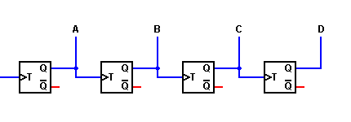

CLK

Timing Diagram of Ripple counter without delays.

CLK

A

BA

CA

DA

Ripple effect (delay)

Timing Diagram of Ripple counter with delays.

CLK

A

BA

CA

DA

In the 4-bit counter, we are using edge-triggered master-slave flip-flops. The output of each flip-flop changes state on the falling edge (1-to-0 transition) of the T input.

The count held by this counter is read in the reverse order from the order in which the flip-flops are triggered. Thus, output D is the high order of the count, while output A is the low order. The binary count held by the counter is then DCBA, and runs from 0000 (decimal 0) to 1111 (decimal 15). The next clock pulse will cause the counter to try to increment to 10000 (decimal 16). However, that 1 bit is not held by any flip-flop and is therefore lost. As a result, the counter actually reverts to 0000, and the count begins again.

A major problem with the counters shown on this page is that the individual flip-flops do not all change state at the same time. Rather, each flip-flop is used to trigger the next one in the series. Thus, in switching from all 1s (count = 15) to all 0s (count wraps back to 0), we don't see a smooth transition. Instead, output A falls first, changing the apparent count to 14. This triggers output B to fall, changing the apparent count to 12. This in turn triggers output C, which leaves a count of 8 while triggering output D to fall. This last action finally leaves us with the correct output count of zero. We say that the change of state "ripples" through the counter from one flip-flop to the next. Therefore, this circuit is known as a "ripple counter."

This causes no problem if the output is only to be read by human eyes; the ripple effect is too fast for us to see it. However, if the count is to be used as a selector by other digital circuits (such as a multiplexer or demultiplexer), the ripple effect can easily allow signals to get mixed together in an undesirable fashion. To prevent this, we need to devise a method of causing all of the flip-flops to change state at the same moment. That would be known as a "synchronous counter" because the flip-flops would be synchronized to operate in unison

A Synchronous Binary Counter

In our initial discussion on counters (A Basic Digital Counter), we noted the need to have all flip-flops in a counter to operate in unison with each other, so that all bits in the output count would change state at the same time. To accomplish this, we need to apply the same clock pulse to all flip-flops.

However, we do not want all flip-flops to change state with every clock pulse. Therefore, we'll need to add some controlling gates to determine when each flip-flop is allowed to change state, and when it is not. This requirement denies us the use of T flip-flops, but does require that we still use edge-triggered circuits. We can use either RS or JK flip-flops for this; we'll use JK flip-flops for the demonstrations on this page.

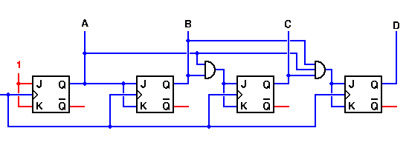

CLK

To determine the gates required at each flip-flop input, let's start by drawing up a truth table for all states of the counter. Such a table is shown to the right.  Looking first at output A, we note that it must change state with every input clock pulse. Therefore, we could use a T flip-flop here if we wanted to. We won't do so, just to make all of our flip-flops the same. But even with JK flip-flops, all we need to do here is to connect both the J and K inputs of this flip-flop to logic 1 in order to get the correct activity.  Flip-flop B is a bit more complicated. This output must change state only on every other input clock pulse. Looking at the truth table again, output B must be ready to change states whenever output A is a logic 1, but not when A is a logic 0. If we recall the behavior of the JK flip-flop, we can see that if we connect output A to the J and K inputs of flip-flop B, we will see output B behaving correctly.  Continuing this line of reasoning, output C may change state only when both A and B are logic 1. Therefore we will need a two-input AND gate at the inputs to flip-flop C.  Flip-flip D requires a three-input AND gate for its control, as outputs A, B, and C must all be at logic 1 before D can be allowed to change state. | States |  |  |  | Count
 | D | C | B | A | Count
 | 0 | 0 | 0 | 0 | 0
 | 0 | 0 | 0 | 1 | 1
 | 0 | 0 | 1 | 0 | 2
 | 0 | 0 | 1 | 1 | 3
 | 0 | 1 | 0 | 0 | 4
 | 0 | 1 | 0 | 1 | 5
 | 0 | 1 | 1 | 0 | 6
 | 0 | 1 | 1 | 1 | 7
 | 1 | 0 | 0 | 0 | 8
 | 1 | 0 | 0 | 1 | 9
 | 1 | 0 | 1 | 0 | 10
 | 1 | 0 | 1 | 1 | 11
 | 1 | 1 | 0 | 0 | 12
 | 1 | 1 | 0 | 1 | 13
 | 1 | 1 | 1 | 0 | 14
 | 1 | 1 | 1 | 1 | 15

A Synchronous Decimal Counter

States |  |  |  | Count | To create a decimal counter, we need to find a way to cut the counting sequence short. The Truth Table to the left shows the actual counting sequence we need. Note that the counting sequence is exactly the same as for the binary counter we saw on the previous page, up through a count of 9. At that point, where the binary counter would continue on to a count of 10, the decimal counter must reset itself to a count of 0.  In this sequence, flip-flops A and C are no problem. Their next states will both be logic 0 whether the next count is 10 or 0. However, flip-flop B would normally switch from logic 0 to logic 1, and must be prevented from doing so. At the same time, flip-flop D, which is at logic 1, must be made to switch back to logic 0.  Since flip-flop D is a logic 1 for only two counts, and only flip-flop A will change state going from count 8 to count 9 in any case, perhaps we can use the D and D' outputs, with gates, to force the desired change in sequence. This is in fact the case, as shown in the demonstration below. Note that we have applied different signals to the J and K inputs of flip-flop D. This is perfectly acceptable, and allows us to reset this flip-flop under the control of a simple two-input AND gate.
D | C | B | A | Count
0 | 0 | 0 | 0 | 0
0 | 0 | 0 | 1 | 1
0 | 0 | 1 | 0 | 2
0 | 0 | 1 | 1 | 3
0 | 1 | 0 | 0 | 4
0 | 1 | 0 | 1 | 5
0 | 1 | 1 | 0 | 6
0 | 1 | 1 | 1 | 7
1 | 0 | 0 | 0 | 8
1 | 0 | 0 | 1 | 9

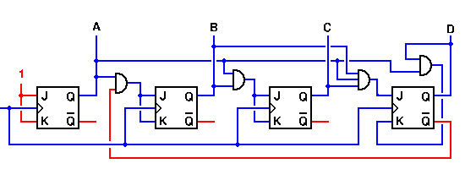

CLK

